27.34: a) and by the righthand rule, the easterly magnetic field results in a southerly force.
b) If the field is southerly, then the force is to the west, and of the same magnitude as part (a), 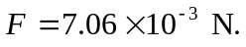
c) If the field is 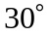 south of west, the force is west of north (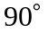 counterclockwise from the field) and still of the same magnitude, 